  Name: | ___________________________________________________ |  |  | Date: ___________
 | Year 9 Mathematics  Test 9, 2015  Topic – Non-linear Functions |  |  | 60  = %
Total Time: | 62 minutes
Total Reading: | 2 minutes
Total Working: | 60 minutes
Weighting: | ______% of the year.
Equipment: | Curriculum Council Formula Sheet; ½ page notes (A4 one side), CAS calculator; Scientific Calculator
SECTION 1: CALCULATOR FREE
Time: | 15 minutes | Marks for Section 1: | 17
Working: | 15 minutes | Equipment Allowed: | Nil

1. | [5 marks: 1, 1, 1, 1, 1]
 | Determine if the following equations are linear, quadratic, hyperbola, circle or none of these
a) |  | b)
c) |  | d)
e)

2. | [8 marks: 3, 5]
The simplest quadratic function: $y=x^{2}$ is shown as a dashed line in each graph.
Describe, using mathematical language, how the quadratic function with a solid line has transformed. Please note there has been no dilation.
a) | 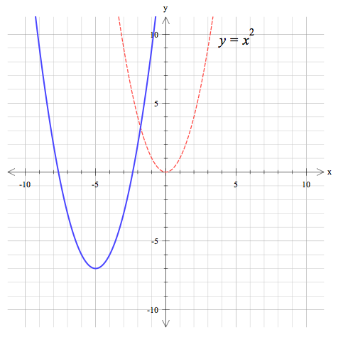
b) | 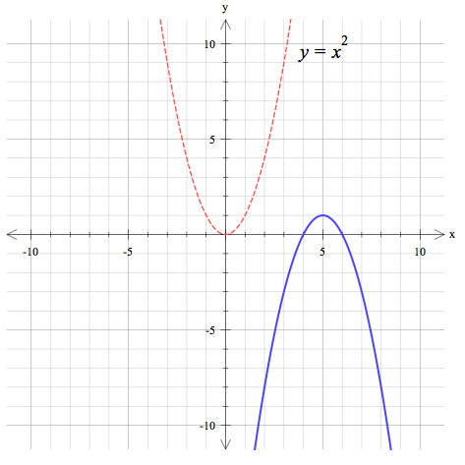

3. | [4 marks: 1, 1, 1, 1]
 | For this graph, state the following key features:
a) | Axis of symmetry | 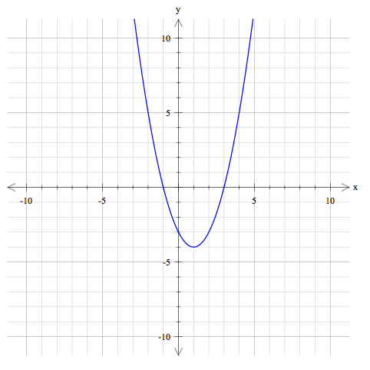
b) | Nature and location of the turning point
c) | The coordinates of the x-intercept(s)
d) | The coordinates of the y-intercept

~ END OF TEST SECTION 1 ~
Name: | ______________________________________ |  |  | Date: ___________
SECTION 2: CALCULATOR ASSUMED
Time: | 45 minutes | Marks for Section 2: | 43
Reading: | 2 minutes | Equipment Allowed: | ½ page notes (A4 one side),  CAS calculator
Working: | 43 minutes

4. | [5 marks]
 | Complete the table of values for the equation shown and plot the related graph
x | -4 | -3 | -2 | -  1 | - ½ | 0 | ½ | 1 | 2 | 3 | 4
y

 | 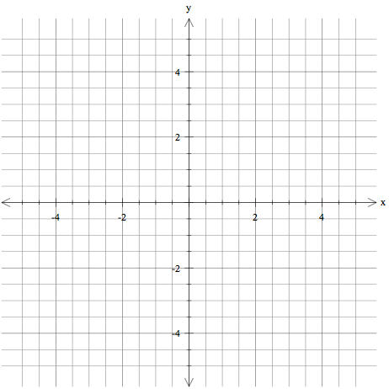

5. | [5 marks]
 | Complete the table of values for the equation shown and plot the related graph
x | -3 | -2 | -  1 | 0 | 1 | 2 | 3 | 4 | 5
y

 | 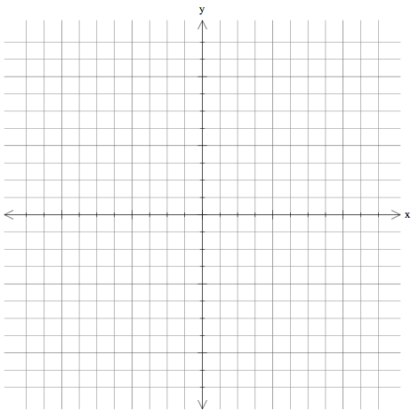

6. | [6 marks: 1, 1, 1, 3]
 | For the equation, $y={(x+4)}^{2}-9$ determine the following:
a) | The y-intercept.
b) | The x-intercept(s).
c) | Nature and location of the turning point.
d) | Sketch the graph.
a) | 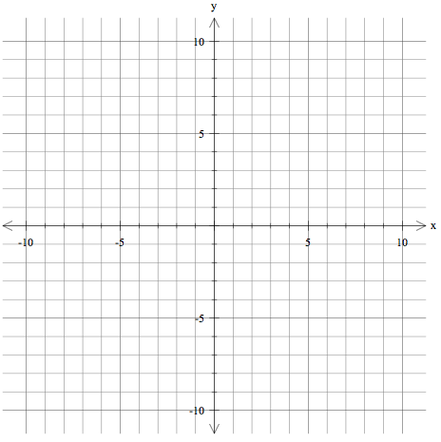

7. | [8 marks: 4, 4 ]
 | The grid below shows the function . On the same grid sketch the following functions (including the correct y-intercept) and label each function clearly.
a) | i) ii)
 | 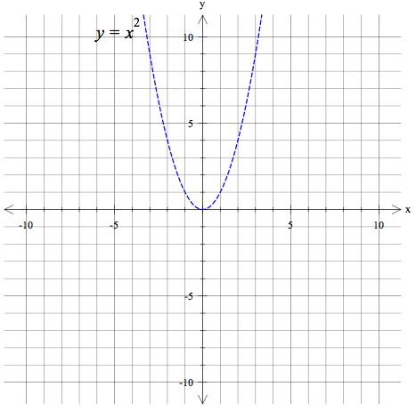
b) | i) ii)
 | 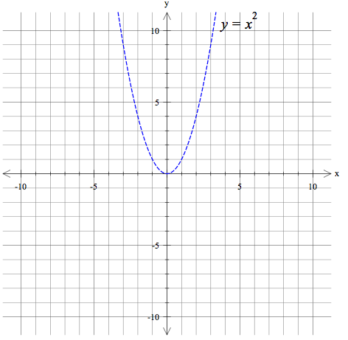
8. | [6 marks: 1, 1, 1, 1, 1, 1]
 | Match each of the following equations to one of the graphs below:
a) | $$y=-5x^{2}$$ | b) | $$y=x^{2}+4$$
c) | $$y={(x-2)}^{2}+3$$ | d) | $$y={\left(x-3\right)}^{2}$$
e) | $$y={(x+2)}^{2}$$ | f) | $$y=\frac{1}{4}x^{2}$$

A | 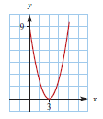 | B | 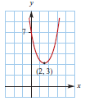
 | Equation: |  | Equation:
C | 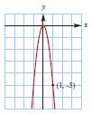 | D | 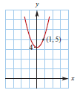
 | Equation: |  | Equation:
E | 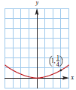 | F | 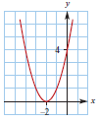
 | Equation: |  | Equation:

9. | [1 mark]
Which graph matches the equation:

GRAPH: A B C D

 | 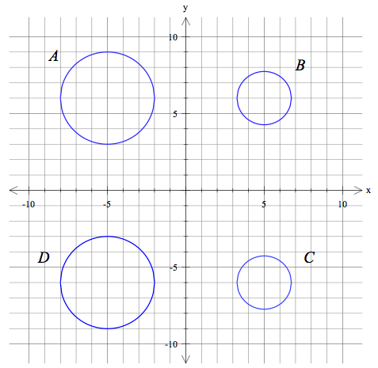

10. | [2 marks: 1, 1]
 | Given the equation:
a) | What is the coordinate of the centre of the graph
b) | What is the radius of the circle

11. | [4 marks: 1, 1, 1, 1]
 | Factorise the following quadratic equations:
a) |  | b)
c) |  | d)
12. | [6 marks: 1, 1, 1, 1, 1, 1]
 | Solve the following quadratic equations:
a) |  | b)
c) |  | d)
e) |  | f)

~ END OF TEST SECTION 2 ~

